CIRCULAR
RTC/CIRCULAR/115/2025 - 26 Date: 05.01.2026
The following members will be in Internal Quality Assurance Cell (IQAC) from the Academic Year 2025 - 26. Any students or Faculty found any difficulties kindly submit the complaint to the Principal Academics.
Dr. C. Krishnaraj | Chairperson | Principal
Dr. B. Nagaraj | Member | Chief Business Officer,  CEO & Vice President, AIC RAISE
Mr. R. Sundar | Member | Advisor
Mr. K. Rajagopal | Member | Advisor
Prof. Jimry Henry | Member | Director of PG Studies
Dr. R. Arunkumar | Member | Associate Vice-president, Center of Excellence
Dr. S. Siva Subramanian, | Member | Director Placements & Training
Mr. S. Arun Vignesh | Member | Dean – Training
Dr. A. Abiram | Member | Director – Research
Dr. S. Seenivasan | Member | Dean-SoM
Dr. S. Manikandan | Member | Dean-SoC
Dr. M. Fathu Nisha | Member | Dean-SoE
Dr. P. Krishnakumar, | Member | Controller of Examination
Dr. A. Rajavel | Member | Director-IQAC
Mr. M. Clement | Member | Asst. Director-IQAC
Mr. R. Jegadeesh Kumar | Member | Coordinator-IQAC
Dr. S. Vinodh | Member | Coordinator-IQAC

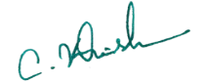
Copy to:
All Hods and department Faculties Principal

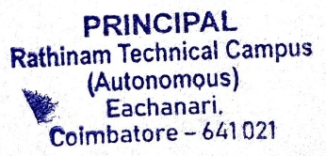
Notice Board for Students
File

