CIRCULAR
RTC/CIRCULAR/111/2025 - 26 Date: 05.01.2026
The following members will be in Internal Complaint Committee (ICC) from academic year 2025 - 26. Any complain can be reported to the committee. The committee can plan for many orientation and awareness programs.
INTERNAL COMPLAINT COMMITTEE | DR. C. KRISHNARAJ | CHAIR PERSON | PRINCIPAL
INTERNAL COMPLAINT COMMITTEE | DR. GEETHA K | MEMBER | PRINCIPAL ACADEMICS
INTERNAL COMPLAINT COMMITTEE | DR. SIVA SUBRAMANIAN S | MEMBER | DIRECTOR PLACEMENT AND HEAD OFFICE AFFAIRS
INTERNAL COMPLAINT COMMITTEE | PROF. H. JIMRY | MEMBER | COORDINATOR, MBA
INTERNAL COMPLAINT COMMITTEE | PROF. A. SARAH RUBY CHRISTINA | MEMBER | HEAD – DIGITAL TRANSFORMATION
INTERNAL COMPLAINT COMMITTEE | DR. D. TAMILSELVI | MEMBER | DEPUTY DIRECTOR- ACADEMICS
INTERNAL COMPLAINT COMMITTEE | PROF.P ANANTHI | MEMBER | HEAD- COE
INTERNAL COMPLAINT COMMITTEE | MRS. GOMATHI R | MEMBER | NON TEACHING
INTERNAL COMPLAINT COMMITTEE | MS. SOWMIYA M | MEMBER | NON TEACHING
INTERNAL COMPLAINT COMMITTEE | MS. VIJAYALAKSHMI N | STUDENT | I MEDICAL ELECTRONICS
INTERNAL COMPLAINT COMMITTEE | MR. YOOKESH S | STUDENT | IV BME
INTERNAL COMPLAINT COMMITTEE | MR. YUVAN AADITHYA | STUDENT | IV AIDS

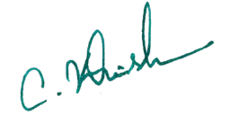
Copy to:
All Hods and department Faculties Principal

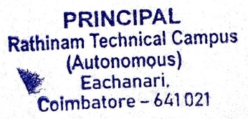
Notice Board for Students
File

