CIRCULAR
RTC/CIRCULAR/117/2025 - 26 Date: 05.01.2026
The following members will be in Industry Committee from the Academic Year 2025 - 26. Any students or Faculty found any difficulties kindly submit the complaint to the Principal Academics.

INDUSTRY COMMITTEE | DR. C. KRISHNARAJ | CHAIR PERSON | PRINCIPAL
INDUSTRY COMMITTEE | DR. S. MANIKANDAN | MEMBER | DEAN SCHOOL OF COMPUTING
INDUSTRY COMMITTEE | MR. K. MUTHUSAMY | MEMBER | HEAD-TECHNICAL COMPETITION & HACKATHON
INDUSTRY COMMITTEE | MR. L. S. KARTHICK | MEMBER | FACULTY MEMBER
INDUSTRY COMMITTEE | MRS. RAJATHI S | MEMBER | FACULTY MEMBER
INDUSTRY COMMITTEE | MRS. C. APARNA | MEMBER | FACULTY MEMBER
INDUSTRY COMMITTEE | MR. V. S. RAMESH | MEMBER | INDUSTRY REPRESENTATIVE
INDUSTRY COMMITTEE | ANEESH MON NARAYAN | MEMBER | INDUSTRY REPRESENTATIVES
INDUSTRY COMMITTEE | MR. M. S. PRADEEPRAJ | MEMBER | INCUBATION/START-UP REPRESENTATIVE
INDUSTRY COMMITTEE | MS. S. ADITHYA | MEMBER | ALUMNI REPRESENTATIVES
INDUSTRY COMMITTEE | MR. S. GOKUL | MEMBER | ALUMNI REPRESENTATIVES
INDUSTRY COMMITTEE | MR.F. ROSHAN BEGUM | MEMBER | STUDENT REPRESENTATIVES
INDUSTRY COMMITTEE | MR.J. PRADEEP | MEMBER | STUDENT REPRESENTATIVES
INDUSTRY COMMITTEE | MR.P. ELANCHEZHIYAN | MEMBER | STUDENT REPRESENTATIVES
INDUSTRY COMMITTEE | MR.A VISHNU PRASANTH | MEMBER | STUDENT REPRESENTATIVES
INDUSTRY COMMITTEE | MR. UJWAL VARMA | MEMBER | ADMINISTRATIVE STAFF

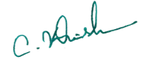
Copy to:
All Hods and department Faculties Principal
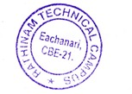
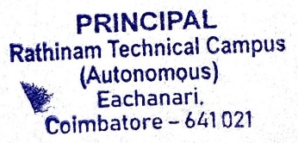
Notice Board for Students
File

