CIRCULAR
RTC/CIRCULAR/118/2025 - 26 Date: 05.01.2026
The following members will be in Grievance Redressal Committee from academic
year 2025 - 26. Any complain can be reported to the committee. The committee can plan for
many orientation and awareness programs.
Grievance Redressal Committee | DR. C. KRISHNARAJ | CHAIR PERSON | PRINCIPAL
Grievance Redressal Committee | DR. GEETHA K | MEMBER | PRINCIPAL ACADEMIC
Grievance Redressal Committee | DR.S. MANIKANDAN | MEMBER | DEAN -SOC
Grievance Redressal Committee | DR. S. SEENIVASAN | MEMBER | DEAN-SMS
Grievance Redressal Committee | DR. M. FATHU NISHA | MEMBER | ASSOCIATE DEAN -SOE
Grievance Redressal Committee | PROF. JIMRY HENRY | MEMBER | DIRECTOR OF PG STUDIES
Grievance Redressal Committee | MR. JAYABAL | MEMBER | OFFICE MANAGER
Grievance Redressal Committee | MR.M. ATHIPATHY | MEMBER | OPERATION MANAGER - PRINCIPAL
Grievance Redressal Committee | MR. JEROM ISAAC T.S | STUDENT | IV CSE
Grievance Redressal Committee | MS.N. ARUNTHATHI | STUDENT | III AIDS

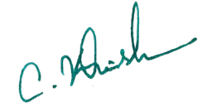
Copy to:
All Hods and department Faculties Principal

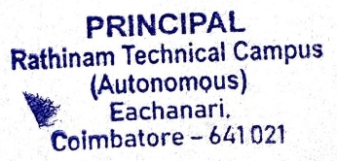
Notice Board for Students
File

