CIRCULAR
RTC/CIRCULAR/116/2025 - 26 Date: 05.01.2026
The following members are appointed to the Counsellor Committee for the Academic Year 2025–26. Students and faculty members experiencing any difficulties are encouraged to approach the Psychiatrist and submit their concerns for appropriate guidance and support

COUNSELLOR COMMITTEE | DR. NITHYA POORANI J | PSYCHIATRIST
COUNSELLOR COMMITTEE | MRS. RAJALAKSHMI M | ASSISTANT PROFESSOR
COUNSELLOR COMMITTEE | MR. RATHINAVEL PANDIAN D | ASSISTANT PROFESSOR
COUNSELLOR COMMITTEE | MS. VENKATALAKSHMI V R | ASSISTANT PROFESSOR
COUNSELLOR COMMITTEE | MRS. S. NITHYAPRIYA | STUDENT COUNSELLER
COUNSELLOR COMMITTEE | MS. AKHIYA SHAJI | STUDENT COUNSELLER

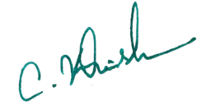
Copy to:
All Hods and department Faculties Principal

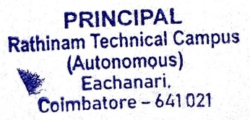
Notice Board for Students
File

