CIRCULAR
RTC/CIRCULAR/110/2025 - 26 Date: 05.01.2026
Anti-Ragging Committee | Dr. C. KRISHNARAJ | CHAIRPERSON | PRINCIPAL
Anti-Ragging Committee | Dr. GEETHA K | MEMBER | PRINCIPAL ACADEMICS
Anti-Ragging Committee | Dr. SIVA SUBRAMANIAN S | MEMBER | DIRECTOR TRAINING & PLACEMENT
Anti-Ragging Committee | Prof. ARUN RAAJ MANICKAJ | MEMBER | HOD/MBA
Anti-Ragging Committee | Dr. MANIKANDAN S | MEMBER | FACULTY MEMBER
Anti-Ragging Committee | Dr. SEENIVASAN S | MEMBER | FACULTY MEMBER
Anti-Ragging Committee | Dr. FATHU NISHA M | MEMBER | FACULTY MEMBER
Anti-Ragging Committee | Prof. JIMRY HENRY | MEMBER | DIRECTOR OF PG STUDIES
Anti-Ragging Committee | Dr. SATISH KUMAR P | MEMBER | HOD/S&H
Anti-Ragging Committee | Dr. RAAJANANTHINI K | MEMBER | ASP/S&H
Anti-Ragging Committee | Dr. SELVA PANDIAN D | MEMBER | HOD/CSE
Anti-Ragging Committee | Dr. ANURATHA K | MEMBER | HOD/MCA
Anti-Ragging Squad | MR. ARULRAJ S | MEMBER | DEPUTY CONTROLLER OF EXAMINATIONS
Anti-Ragging Squad | MR. PRABHU T | MEMBER | ASSISTANT PROFESSOR, AGRICULTURAL
Anti-Ragging Squad | MS. SRUTHILAYA U | MEMBER | ASSISTANT PROFESSOR, BIOTECH
Anti-Ragging Squad | MR. LOKESHKIRAN P | MEMBER | ASSISTANT PROFESSOR, CSE
Anti-Ragging Squad | MR. KARTHICK L S | MEMBER | ASSISTANT PROFESSOR, ECE
Anti-Ragging Squad | MRS. APARNA C | MEMBER | ASSISTANT PROFESSOR, IT
Anti-Ragging Squad | MR. THANGAPANDIAN P | MEMBER | ASSISTANT PROFESSOR, MECHANICAL
Anti-Ragging Squad | MRS. PRAKASH R | MEMBER | ASSISTANT PROFESSOR, S&H
Anti-Ragging Squad | MS. NANDHINI S | MEMBER | STUDENT
Anti-Ragging Squad | MR. MARIMUTHU | MEMBER | PHYSICAL DIRECTOR
For the Academic Year 2025 - 26, the following members will be in Anti ragging committee. The committee will plan for all activities related to Anti Ragging.
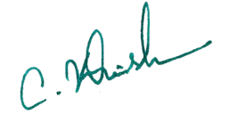
Copy to:
All Hods and department Faculties Principal
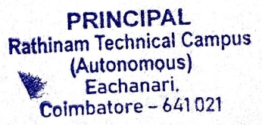
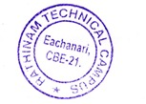
Notice Board for Students
File

